Beverage Fetching Robot

Derek Schmidlkofer
Homework 2
ECE 590
5-8-06

1. Introduction:

The goal of this assignment is to design an arbitrary data bus (DB) with a separate controller unit (CU). An interesting project would be to design a robot that would drive from one room in a house to the kitchen, wait for a beverage to be placed on it, and then return. The DB will handle sensor interpretation, while the CU will issue commands to the motors.

2. Beverage Fetching Robot:

You’re sitting on the sofa watching the big playoff game, when you feel the sudden urge for a cola. What do you do? Get up and potentially miss the greatest play in sports history? No way, send the robot to get one for you. But how does the robot know how to make its way to the kitchen? Simple, just draw a contrasting line from where you are to the kitchen, i.e. if the floor is light colored use a black line and if it’s dark use a white line. For optimal performance, the line should be about half an inch thick. Then place a slim puck like magnet at each end of the line and your set. Place the robot on the magnet in the room that is not the kitchen, with its back to the direction of the line. This is starting position. By pressing the “Go” button, the robot will turn 180° follow the line; stopping if an obstacle blocks its path, then it resumes its forward progression once the obstruction is cleared. Once in the kitchen, it will wait for someone to place a drink on top of it. It then turns around and deliver the beverage to the person waiting in the other room, again following the line and avoiding obstacles.

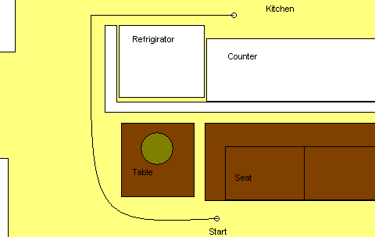
Figure 1: Example of Path Layout
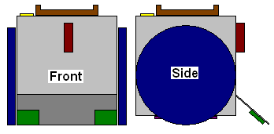
Figure 2: Possible robot configuration: with wheels,
‘Go’ button, drink indicator, magnetic sensor,
line sensors, and object sensor

3. Robot Design:

The circuit design of the robot is broken into several parts. The two components that this report focuses on are the control unit (CU) and the data bus (DB). The DB is responsible for checking the line and optical sensors against a threshold value to simplify the data before sending it to the CU. The CU then uses all the sensor inputs to issue motor commands.

Figure 3: Control Unit (CU) and Data Bus (DB) with Inputs/Outputs

3.1 The Control Unit (CU):

The CU stays in a stand by mode until the ‘go’ input is initiated by the user. Once the go command has been issued, the robot rotates 180° on the home position, and then proceeds to follow a designated line into the kitchen. During the process of following the line, the robot is regularly checking the object, line, and destination sensors. The destination sensor is immediately available to the CU, but it has to send a request to the DB for the results of the line and object sensors. The robot will stop if it sees an obstacle one foot in front of it. Once the obstacle is removed, the robot will continue to follow the line using the line sensors. If the right line sensor detects the line, it will call for the robot to turn right. The left line sensor will trigger the robot to turn left. The robot will continue to follow the line until the destination sensor is activated. This sensor uses a magnetic switch that toggles as is passes over reversed polarity magnets. Example, the magnet in the home position is facing north pole up and the magnet in the kitchen is facing south pole up. Once in the kitchen, the robot will wait for a drink to be placed on top of it. The ‘drink’ sensor uses a switch that detects if an object of a certain mass or greater is place upon it. Now that the robot has the drink, it will turn around and return to the home position, again following the line while avoiding obstacles. The commands issued to the motor controller are as follows:

Table 1: Motor Controller Commands

Table 2: CU Inputs and Outputs
Go
Rotate 180°
Object
Line L
Line R
Stop
Turn Left
Turn Right
Forward
Check Sensors
Destination Reached
Line Follow
Drink
Stop
Rotate 180°
Line Follow
Off
Key
Yes
No
3.1.1 CU Flow Chart:
3.1.2 CU VHDL Code:
------------------------------------------------------------------------------------------------------------
library ieee;
use ieee.std_logic_1164.all;
use work.all;

entity CU is port (
clk : in std_logic;
go : in std_logic;
drink : in std_logic;
destination : in std_logic;
sensor_check_done : in std_logic;
line_l_status : in std_logic;
line_r_status : in std_logic;
object_status : in std_logic;
sensor_check : out std_logic;
motor : out std_logic_vector(2 downto 0));
end CU;

architecture structural of CU is
begin
process
begin
sensor_check <= '0';
motor <= "000"; --ensure that the robot is stopped
wait until go = '1'; --wait for "go" command
motor <= "110"; --command to rotate 180 degrees

line_follow1 : while destination = '0' loop --kitchen stop
point will set destination = '1'
wait until clk = '1';
sensor_check <= '1'; --call to data bus for sensor info
wait until sensor_check_done = '1'; --Wait for sensors to be
checked
sensor_check <= '0'; --reset call for data bus sensor info
if object_status = '1' then motor <= "000"; --object blocking
path, stop
elsif line_l_status = '1' then motor <= "011"; --turn left
elsif line_r_status = '1' then motor <= "010"; --turn right
else motor <= "001"; --forward
end if;
end loop line_follow1;

motor <= "000"; --stop
wait until drink = '1'; --wait for drink to be placed on robot
motor <= "110"; --command to rotate 180 degrees

line_follow2 : while destination = '1' loop --kitchen stop
point will set destination = '1'
wait until clk = '1';
sensor_check <= '1'; --call to data bus for sensor info
wait until sensor_check_done = '1'; --Wait for sensors to be
checked
sensor_check <= '0'; --reset call for data bus sensor info
if object_status = '1' then motor <= "000"; --object blocking
path, stop
elsif line_l_status = '1' then motor <= "011"; --turn left
elsif line_r_status = '1' then motor <= "010"; --turn right
else motor <= "001"; --forward
end if;
end loop line_follow2;

motor <= "000"; --Stop
end process;
end structural;

------------------------------------------------------------------------------------------------------------

3.2 The Data Bus (DB):

The DB waits for a call from the CU to send it sensor information. It then compares the sensor data from the AD Converter with a threshold value stored in memory to determine what values should be sent to the CU. After the DB calculations are finished, it sends a signal to the CU informing it that all sensor data is ready.

Table 3: DB inputs and outputs

3.2.1 Sensors:
A good line following sensor would be the Fairchild QRB1134. It is an infrared photo reflector sensor containing two elements, one which emits a beam of infrared light and the other which detects that light. An object in front of this sensor will reflect light. A daylight filter is built into the sensor in order to reduce interference from ambient lighting. Its optimal sensing distance is about 0.2 inches. Figure 4: Fairchild QRB1134
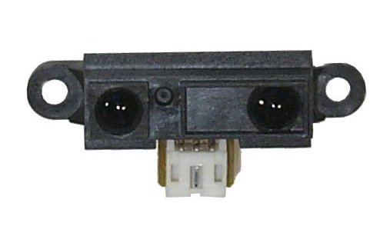
The Sharp GP2D12 infrared distance measuring sensor is accurate enough for object detection. It can accurately determine range to target between 10cm and 80cm and can be used as a proximity detector to detect objects between 0cm and 130cm.

Figure 5: Sharp GP2D12
3.2.2 Data Bus Structure:

Information can pass through the DB using a serial or parallel procedure. In this particular case, the input bits from the sensors are being compared to a threshold value from memory. The comparison process examines the bits and looks for instances where the input and threshold bits differ. If this process is done using a parallel configuration, first all the bits from the input are compared to the all of the bits from the threshold. Then the circuit needs to look through the results to find instances of discrepancy. Finally, it determines which values, between the input and threshold, are larger or smaller, depending upon the circumstances and outputs the result. In a serial procedure, the bits are compared one by one. Starting with the most significant bit (MSB) the circuit is looking for the first instance of a difference in values between the input and threshold. Once a difference is found, the process is stopped and a result is output. The use of a serial process works best in this application because it produces a smaller circuit and there are fewer computation steps in the process. Bellow is an example of a possible comparison block that could be used in the DB. Three of these blocks could be arranged in parallel with their stop outputs linked together with a three input AND gate to output the sensor check done bit to the CU.

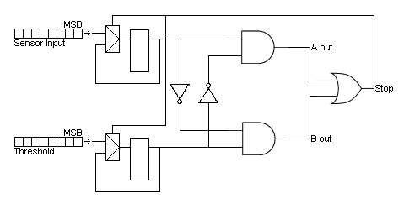
Figure 6: DB Serial Block

Table 4: DB Serial Block Truth Table and Outputs
3.2.3 DB VHDL Code:
------------------------------------------------------------------------------------------------------------
library ieee;
use ieee.std_logic_1164.all;
use robot.all;

entity DB is port (
line_l : in std_logic_vector(7 downto 0);
line_r : in std_logic_vector(7 downto 0);
object : in std_logic_vector(7 downto 0);
sensor_check : in std_logic;
line_l_threshold : in std_logic_vector(7 downto 0);
line_r_threshold : in std_logic_vector(7 downto 0);
object_threshold : in std_logic_vector(7 downto 0);
sensor_check_done : out std_logic;
line_l_status : out std_logic;
line_r_status : out std_logic;
object_status : out std_logic);
end DB;

architecture procedure of DB is
begin
process
begin
wait until sensor_check = '1'; --wait for call from CU
if object < object_threshold then object_status <= '1';
--check for object
else object_status <= '0'; --no object
end if;
if line_l > line_l_threshold then line_l_status <= '1';
--check for line
else line_l_status <= '0'; --no line
end if;
if line_r > line_r_threshold then line_r_status <= '1';
--check for line
else line_r_status <= '0'; --no line
end if;
sensor_check_done <= '1'; --tell CU that DB is done
sensor_check_done <= '0'; --reset check bit
end process;

end procedure;
------------------------------------------------------------------------------------------------------------

4. Test Bench VHDL Code:
------------------------------------------------------------------------------------------------------------
library ieee;
use ieee.std_logic_1164.all;
use work.all;

entity testcu is
end testcu;

architecture test of testcu is

component cu port (
clk : in std_logic;
go : in std_logic;
drink : in std_logic;
destination : in std_logic;
sensor_check_done : in std_logic;
line_l_status : in std_logic;
line_r_status : in std_logic;
object_status : in std_logic;
sensor_check : out std_logic;
motor : out std_logic_vector(2 downto 0));
end component;

signal clk, go, drink, destination, sensor_check_done:std_logic;
signal line_l_status, line_r_status, object_status:std_logic;
signal sensor_check:std_logic;
signal motor:std_logic_vector(2 downto 0);

begin
uut: cu port map(clk, go, drink, destination, sensor_check_done, line_l_status,
line_r_status, object_status, sensor_check, motor);
waveformgen:process
constant interval: time:= 20 ns;
begin
clk <= '0';
go <= '0';
drink <= '0';
destination <= '0';
sensor_check_done <= '0';
line_l_status <= '0';
line_r_status <= '0';
object_status <= '0';

wait for interval;
go <= '1';
wait for interval;
go <= '0';

wait for interval; --no object or line
clk <= '1';
wait for interval;
clk <= '0';
wait for interval;
sensor_check_done <= '1';
clk <= '1';
wait for interval;
clk <= '0';
wait for interval;
clk <= '1';
wait for interval;
sensor_check_done <= '0';
clk <= '0';

wait for interval; --an object
clk <= '1';
object_status <= '1';
wait for interval;
clk <= '0';
wait for interval;
sensor_check_done <= '1';
clk <= '1';
wait for interval;
clk <= '0';
wait for interval;
clk <= '1';
object_status <= '0';
wait for interval;
sensor_check_done <= '0';
clk <= '0';

wait for interval; --line L
clk <= '1';
line_l_status <= '1';
wait for interval;
clk <= '0';
wait for interval;
sensor_check_done <= '1';
clk <= '1';
wait for interval;
clk <= '0';
wait for interval;
clk <= '1';
line_l_status <= '0';
wait for interval;
sensor_check_done <= '0';
clk <= '0';

wait for interval; --line R
clk <= '1';
line_r_status <= '1';
wait for interval;
clk <= '0';
wait for interval;
sensor_check_done <= '1';
clk <= '1';
wait for interval;
clk <= '0';
wait for interval;
clk <= '1';
line_r_status <= '0';
wait for interval;
sensor_check_done <= '0';
clk <= '0';

wait for interval;
clk <= '1';
wait for interval;
clk <= '0';

wait for interval; --destination reached
clk <= '1';
destination <= '1';
wait for interval;
clk <= '0';

wait for interval; --drink received
clk <= '1';
drink <= '1';
wait for interval;
clk <= '0';

wait for interval;
clk <= '1';
wait for interval;
clk <= '0';
wait for interval;
clk <= '1';
wait for interval;
clk <= '0';

wait for interval; --home
destination <= '0';
wait;

end process waveformgen;
end test;
------------------------------------------------------------------------------------------------------------
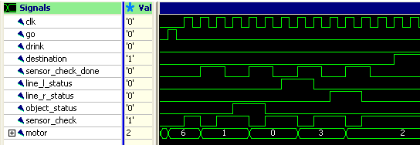
Figure 7: Test Bench Results for CU
------------------------------------------------------------------------------------------------------------

library ieee;
use ieee.std_logic_1164.all;
use robot.all;

entity test_robot is
end test_robot;

architecture test of test_robot is

component CU port (
go : in std_logic;
drink : in std_logic;
destination : in std_logic;
sensor_check_done : in std_logic;
line_l_status : in std_logic;
line_r_status : in std_logic;
object_status : in std_logic;
sensor_check : out std_logic;
motor : out std_logic_vector(2 downto 0));
end component;

component DB port (
line_l : in std_logic_vector(7 downto 0);
line_r : in std_logic_vector(7 downto 0);
object : in std_logic_vector(7 downto 0);
sensor_check : in std_logic;
line_l_threshold : in std_logic_vector(7 downto 0);
line_r_threshold : in std_logic_vector(7 downto 0);
object_threshold : in std_logic_vector(7 downto 0);
sensor_check_done : out std_logic;
line_l_status : out std_logic;
line_r_status : out std_logic;
object_status : out std_logic);
end component;

signal go : std_logic;
signal drink : std_logic;
signal destination : std_logic;
signal sensor_check_done : std_logic;
signal line_l_status : std_logic;
signal line_r_status : std_logic;
signal object_status : std_logic;
signal sensor_check : std_logic;
signal line_l : std_logic_vector(7 downto 0);
signal line_r : std_logic_vector(7 downto 0);
signal object : std_logic_vector(7 downto 0);
signal line_l_threshold : std_logic_vector(7 downto 0);
signal line_r_threshold : std_logic_vector(7 downto 0);
signal object_threshold : std_logic_vector(7 downto 0);
signal motor : std_logic_vector(2 downto 0);

begin
-- uut: drink_fetching_robot port map(go, drink, destination, sensor_check_done, line_l_status, line_r_status, object_status, sensor_check, line_l, line_r, object, line_l_threshold, line_r_threshold, object_threshold, motor);
waveformgen: process
begin
go <= '0'; --set initial values
drink <= '0';
destination <= '0';
sensor_check_done <= '0';
line_l_status <= '0';
line_r_status <= '0';
object_status <= '0';
sensor_check <= '0';
line_l <= "00001000"; --no line
line_r <= "00001000"; --no line
object <= "00001000"; --no object
object_threshold <= "00000100";
line_l_threshold <= "00010000";
line_r_threshold <= "00010000";

go <= '1' after 1 sec; --start robot
object <= "00000010" after 3 sec; --object spotted
object <= "00001010" after 4 sec; --object removed
line_l <= "00100000" after 3 sec; --line l spotted
line_l <= "00001000" after 5 sec; --line l removed
line_r <= "00100000" after 6 sec; --line r spotted
line_r <= "00001000" after 7 sec; --line r removed
destination <= '1' after 8 sec; --in kitchen
drink <= '1' after 9 sec; --received drink
object <= "00000010" after 13 sec; --object spotted
object <= "00001010" after 14 sec; --object removed
destination <= '0'after 15 sec; --done

end process waveformgen;
end test;
------------------------------------------------------------------------------------------------------------

5. Conclusion:

The goal of this assignment was to design an arbitrary data bus (DB) with a separate controller unit (CU). A robot was designed that would drive from one room in a house to the kitchen, wait for a beverage to be placed on it, and then return. The DB handled sensor readings, while the CU will issued commands to the motors. Together they operated as a single entity that processed and interpreted sensor data in order to control the movement of the robot.

This project could be expanded by adding more sensors and functionality to the robot. Perhaps a positioning system that would eliminate the need for a line could be added. Two or more object sensor on the front of the robot would allow it to maneuver around objects instead of just waiting for them to bee move from its path. The robot could also be programmed to perform more tasks, not just getting drinks. There are many possibilities.

